The Things They Carried by Tim O’Brien Project

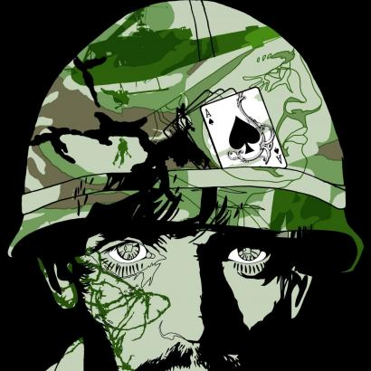
The purpose of this project is for you to analyze one character across more than one story to understand him/her more deeply.

Visual Text
You will create a visual that portrays:
- the character’s personality and experiences
- five of the things the character carried: physical, emotional, or symbolic. You must explain the importance of the “thing” carried for the character.
- three quotes with page numbers about the character from two or more stories in the novel. These quotes can either be said by or about the character.

Your visual can be:
- collage
- artwork / illustration
- poster
- slideshow
- a book jacket for a book about that character
- a CD jacket for a CD by/about the character (include a list of at least 10 songs)
If you have another idea, see Ms. Bennett.

In creating your project, think about the following questions. You do not need to necessarily answer any of them, but instead use them as a guide.
- What do the things he/she carries show about him/her?
- What was a defining moment for the character?
- What does the character hide?
- Do the character’s actions match his/her inner thoughts?
- Does the character change?
- Is the character heroic? Tragic?
- Judge the character’s decisions –did he/she do the right thing?
- Does this character remind you of someone you know, or a character from another text, or someone in the real world?

Requirements:
- Make sure your visual doesn’t just draw on the OBVIOUS traits of the character. Analyze your character and try to figure out what O’Brien wanted you to know about him/her.
- Either on your visual or on a separate sheet of paper (whichever one is more aesthetically pleasing) TYPE an analysis for each quote (3-5 sentences in length) included and a paragraph explaining your reasoning for choosing your character.

Some Resources:
If you open this document on your computer, you can click on the titles of the resources to link to the webpage listed.

Veteran’s History Project (http://www.loc.gov/vets/)
Search the Veteran’s History Project by war to find stories from Vietnam Veterans.

Teaching With Documents: The War in Vietnam—A Story in Photographs
http://www.archives.gov/education/lessons/vietnam-photos/
Vietnam Veterans Memorial
http://www.nps.gov/vive/
Experiencing War: Forever a Soldier
http://www.loc.gov/vets/stories/foreverasoldier/index.html
Experiencing War: Stories from the Veterans History Project
http://www.loc.gov/folklife/vets/stories/ex-war-home.html
A People at War
http://www.archives.gov/exhibits/a_people_at_war/a_people_at_war.html

Viet Nam War Overview (http://vietnam.vassar.edu/overview.html)
This site presents an historical overview of the Viet Nam War by Robert Brigham, highlighting key events, historical documents, and links.

Photo Essay of Vietnam War
http://www.vietnampix.com/index.html

Presentation: Your project is due January 18th . It must be uploaded in turnitin.com by midnight of that night. You will present your visual on the 18th, explaining the character and how the visual represents him/her.

The Things They Carried Project Rubric

Student Name: _______________________________

Character Chosen: _______________________________

Choice of Visual: _______________________________

____/20 Visual accurately portrays the character’s personality and experiences.

____/20 Visual portrays and explains five things (4 points each) the character carried. These things can be physical, emotional, or symbolic.

____/30 Visual incorporates three quotations (3 points each) about the
character from two or more stories in the novel. Includes page numbers (2 points each) and analysis (5 points each) of quotes.

____/15 Visual is clear and professional in appearance, with no errors in spelling, etc.

____/15 Visual is creative and interesting.
_____________________

____/100

__________ Written text was not uploaded into turnitin.com, and therefore, the project was not graded and the student received a zero.

